Investigating Discharging Capacitors STUDENT
Introduction
In this practical activity you will be observing the exponential nature of potential difference as a capacitor is discharged.
Aim
- To observe the change in voltage across capacitors as they are being discharged.
- To take measurements to allow confirmation of exponential formulae learned.
- Calculating the capacitance of the capacitors used in the experiment
Intended class time
- 60 to 90 minutes
Equipment
- University of Southampton’s ‘Music Mixer’ Kit with AA battery and 3 jumpers
- 1 voltmeter/multimeter
- 2 connecting leads and 2 crocodile clips
Procedure
Single Capacitor:
The Music Mixer boards have a dedicated section on the lower left to experiment with capacitors. Depending on how jumpers are connected on J1 to J6 pin headers, it is possible to test discharging of capacitors in series or in parallel.
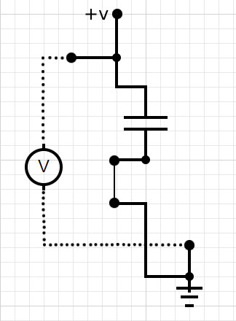
Make sure the S2 switch is set to the left-position (“CHARGE”) when charging. By connecting a jumper across either the J1 or the J2 header only, we can complete a circuit which charges the capacitors C4 or C5 respectively. Measuring the voltage in this setup is unnecessary because charging is very rapid as there are no resistors in the charging circuit, but a voltmeter can still be connected to ensure that the capacitor is charged.
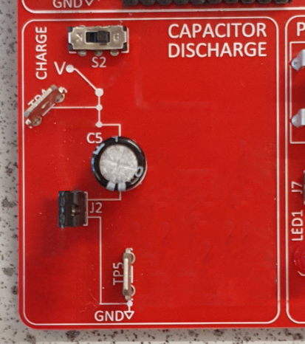
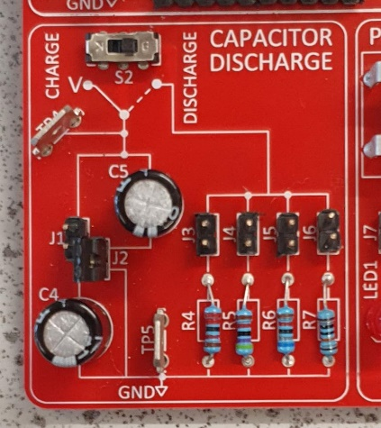
- After the capacitor is charged, connect a jumper across one or multiple pin headers on the discharging side (J3 to J6) depending on which sets of resistors (R4 to R7) are to be tested.
- Connect a voltmeter to the circuit using crocodile clips and the TP4 and TP5 test points.
- Set the switch S2 to the right-position (“DISCHARGE”). This should begin the discharging.
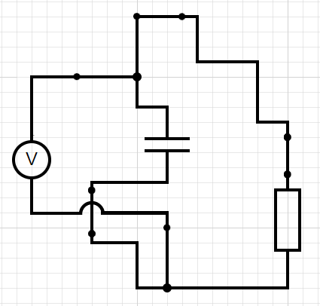
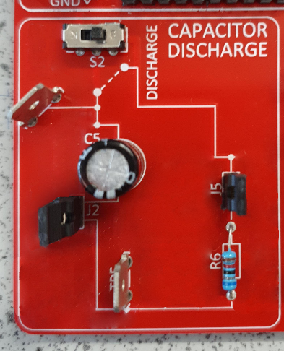
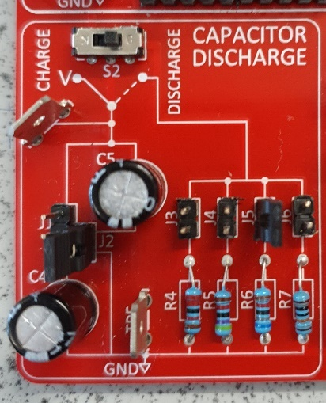

- Measure the change in voltage across the capacitor over time with a stopwatch, with an interval every 15 seconds. Record your measurements in a table.
- Plot the graph of the voltage against time over several minutes or whatever time period is appropriate for the given capacitance.
- Using linear interpolation or other numerical or graphical methods, find a line of best fit for your graph.

Capacitors in Series:
In order to test the effective capacitance of the circuit when C4 and C5 are connected in series, the circuit must first be connected by joining the J1 and J2 pin headers with a single jumper and the capacitors should be charged by switching S2 to K position.
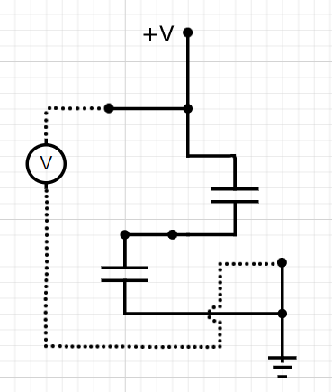
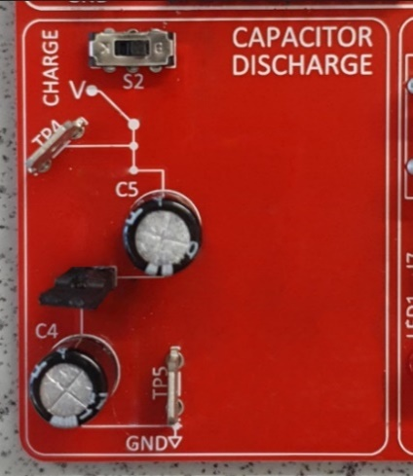
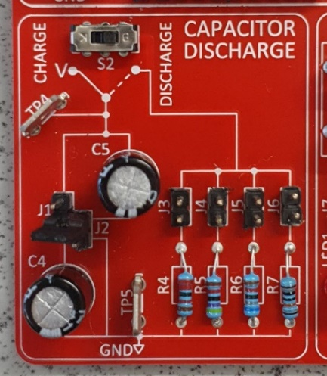
After the capacitors are charged, connect a jumper across one or multiple resistor pin headers, similar to the setup with one capacitor. Follow the same instructions and plot a new Voltage-Time graph for capacitors in series.
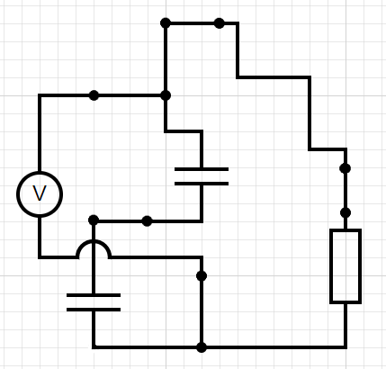
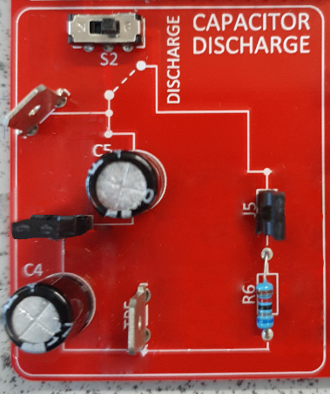
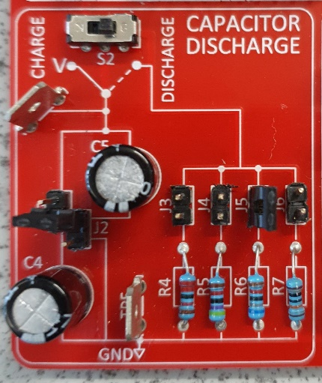
Capacitors in Parallel:
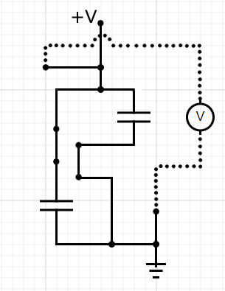
Charge the capacitors in parallel by joining the J1 and J2 pin headers separately as illustrated below.
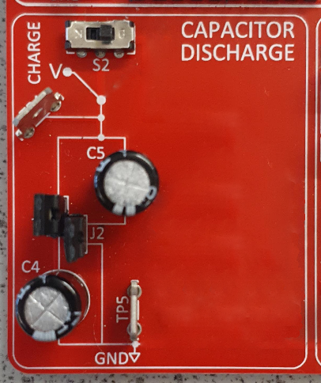
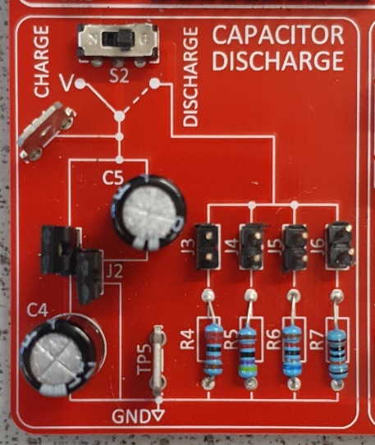
Once again, after the capacitors are charged, follow the same instructions. Record your measurements of the potential difference over a time period and plot a graph demonstrating change in V as time progresses.
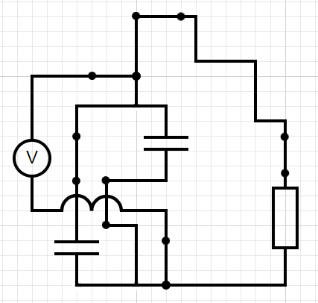
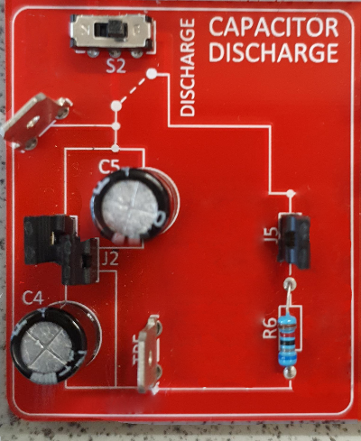
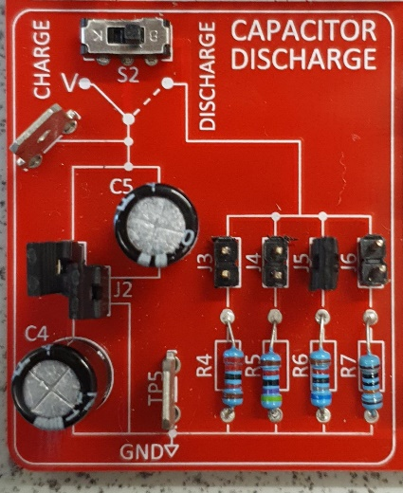

Evaluation
- Comment on the shapes of your graphs. Explain whether they agree with what would be expected from the formulae you’ve learned.
- Using your graphs, calculate graphically or numerically (with regression analysis) the capacitance of the capacitors.
- Comment on whether your results for capacitors in series and in parallel agree with what would be expected.
Extension
- Suggest how the current across the circuits during discharge can be measured.
- Suggest how you can make voltage and current measurements as the capacitor(s) are charging.

To submit
For this piece of work to count towards Practical Activity Group 9 of the GCE Physics Practical Endorsement you should have evidence of the data collected from your group. You should have used the data collected to plot discharging characteristics and been able to calculate a value for the capacitor.

Criteria | Description
2.1 (b) | safely and correctly use a range of practical equipment and materials
2.1 (c) | follow written instructions
2.1 (d) | make and record observations/measurements
2.1 (e) | keep appropriate records of experimental activities
2.1 (f) | present information and data in a scientific way
2.1 (g) | use appropriate software and tools to process data, carry out research and report findings
2.1 (j) | use a wide range of experimental and practical instruments, equipment and techniques appropriate to the knowledge and understanding included in the specification.
2.2 (b) | use of appropriate digital instruments, including electrical multimeters, to obtain a range of measurements (to include time, current, voltage, resistance and mass)
2.2 (f) | correctly constructing circuits from circuit diagrams using DC power supplies, cells, and a range of circuit components, including those where polarity is important
2.2 (k) | use of ICT such as computer modelling, or data logger with a variety of sensors to collect data, or use of software to process data
CPAC (2) | Applies investigative approaches and methods when using instruments and equipment
CPAC (3) | Safely uses a range of practical equipment and materials
CPAC (4) | Makes and records observations

