In this practical you will use the top half of the Music Mixer circuit board as shown below.
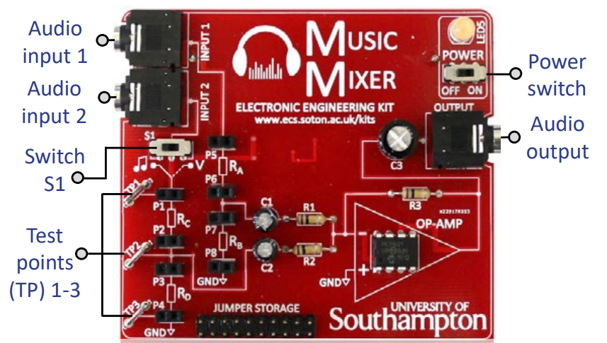

This practical is split into three parts:
- Part 1 – you will experiment with a potential divider circuit.
- Part 2 – you will see how a potential divider circuit works with AC electrical signals.
- Part 3 – you will investigate superposition and interference of AC electrical signals.

You will need the following equipment:
- music mixer circuit board kit
- 4x 10kΩ resistors, 2x 1kΩ resistors and 2x 100kΩ resistors
- multimeter and probes
- 3 sheets plain paper
- mobile phone with headphone port and “Function Generator” app installed
- oscilloscope and probes
Part 1: potential dividers

1. Ensure switch S1 is switched to the right. This isolates a single part of the circuit which acts as a potential divider with three test points (TP1, 2 & 3) where you can connect a voltmeter.

2. Insert two 1kΩ resistors into the connections as shown below in positions R_{C} and R_{D}
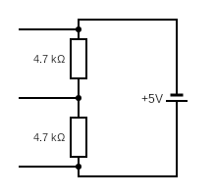
TP1
TP2
TP3
1 kΩ
1 kΩ

3. Connect the voltmeter to measure the voltage between test point 1 and test point 3. Note down this supply EMF into table 1 below.

4. Predict your expected values for the potential difference across R_{C} and R_{D} using the potential divider equation. Record these values into table 1 below.

5. Measure the actual potential difference across R_{C} using a voltmeter connected between TP1 and TP2. Record this into table 1 below.

5. Measure the actual potential difference across R_{D} using a voltmeter connected between TP2 and TP3. Record this into the table 1 below.

6. The resistors have a tolerance of ±5% (gold band) or ±1% (brown band). Check if your measured potential difference values are within this range.

7. Repeat steps 4 – 6 for three other combinations of resistors of your choosing.
Table 1: potential divider results
Supply EMF (V) | R_{C} (Ω) | R_{D} (Ω) | Expected V_{C} (V) | Expected V_{D} (V) | Measured V_{C} (V) | Measured V_{D} (V)
 | 1K | 1K

8. The fixed value resistors can be replaced with light dependent resistors (LDRs). Connect an LDR in position R_{C}, and a 1kΩ resistor in position R_{D.}

9. Measure the potential difference across the LDR and calculate the resistance of the LDR at different light intensities. Try measuring with the LDR uncovered and then obstructing the light with paper (1, 2 and 3 sheets thick). Does the resistance increase or decrease with light level?

Table 2: potential divider with an LDR results
Supply EMF (V) | R_{C} (Ω) | R_{D} (Ω) | Measured V_{OUT} (V) | Calculate R_{C} (Ω)
 | LDR Ambient | 1K
 | LDR (1 sheet) | 1K
 | LDR (2 sheets) | 1K
 | LDR (3 sheets) | 1K

Part 2: potential dividers with AC signals

Potential dividers can also be used to divide an AC signal. We are now going to connect the Music Mixer to a signal generator and an oscilloscope.

1. Plug in four 10kΩ resistors in positions R_{A}, R_{B}, R_{C} and R_{D.} Ensure switch S1 is switched to the left.

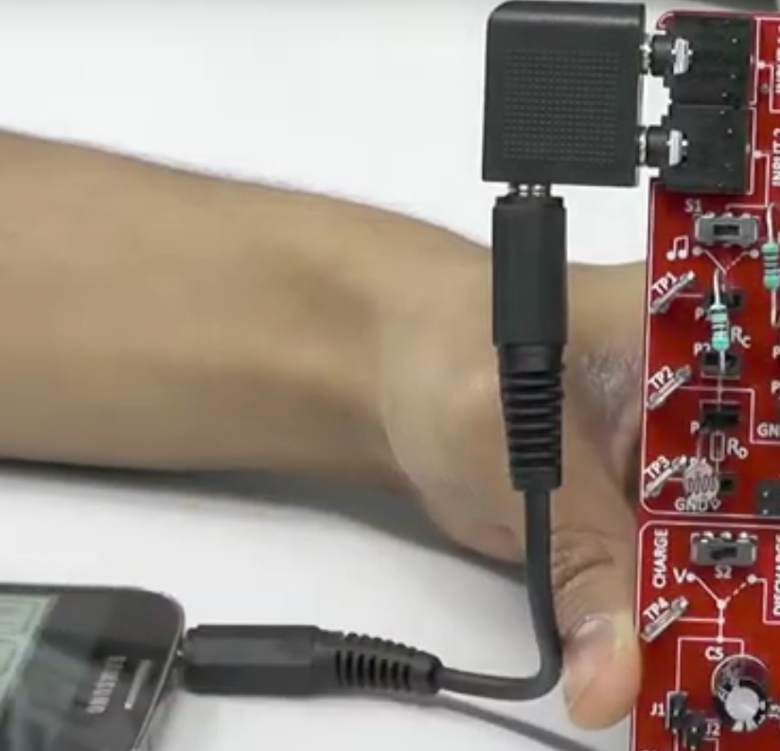
2. Plug the headphone splitter into inputs 1 and 2 and use a 3.5mm AUX lead to connect the mobile phone’s headphone port to the splitter like this:

3. Connect the output of the Music Mixer circuit board to the oscilloscope using a 3.5mm plug to bare wires cable. Connect the oscilloscope probe to the bare wires. The main part of the probe should clip onto the red coloured wire, and the crocodile clip should connect to the black wire.

4. Launch the “Function Generator” app on the phone.
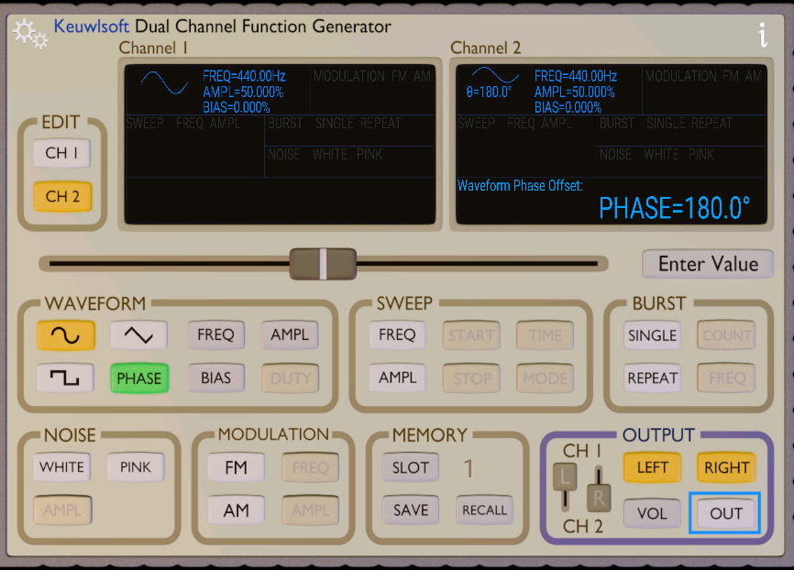

Note: When using the app, make sure that the output is off in the app (circled in red in the image above) when plugging and unplugging from the board. Also limit the volume in the phone to <75% of the maximum volume.

5. Output a wave on just channel 1. To turn off channel 2, un-click the “RIGHT” button. Then click the “OUT” button to turn on the output.

6. Observe the waveform on the oscilloscope. Adjust the timebase and volts/div settings in order to view the waveform easily on the oscilloscope screen.

7. Adjust the frequency and amplitude of the wave using the controls in the Function Generator app. Verify that the waveform on the oscilloscope changes as you would expect.

8. Reset the amplitude to 100% and the frequency to 400Hz. Adjust the settings on the oscilloscope until you can view several cycles of the wave on the oscilloscope screen. Sketch the waveform on the first blank oscilloscope axis on the next page.

9. Replace resistor R_{A} with a 1kΩ and 100kΩ resistor in turn. Do not change any settings on the Function Generator. Each time sketch the output on the oscilloscope axis on the next page, and measure the amplitude.

10. Replace resistor R_{A} with an LDR. Observe the effect of changing the light level on the output waveform.

11. Keeping resistor R_{A} as an LDR, replace the oscilloscope with a pair of headphones. Listen to the output as the light level is changed.
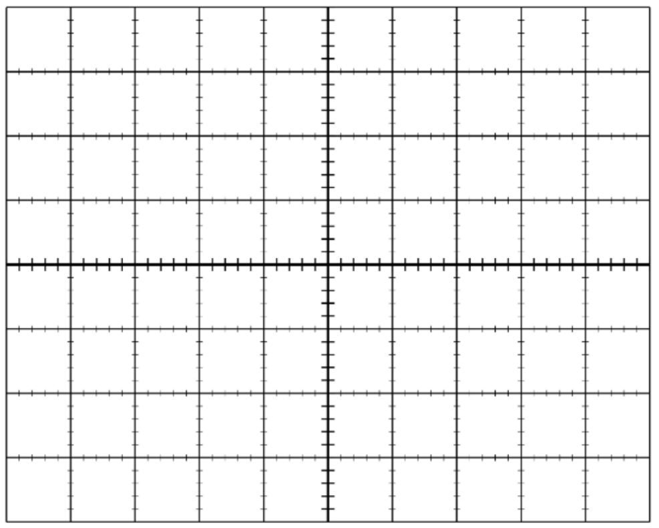
Original waveform
R_{A} = 10 kΩ
R_{B} = 10 kΩ

Amplitude =

Waveform 2
R_{A} = 1 kΩ
R_{B} = 10 kΩ

Amplitude =

Waveform 3
R_{A} = 100 kΩ
R_{B} = 10 kΩ

Amplitude =

Part 3: superposition and interference of AC electrical signals
The circuitry to the right of the potential dividers is an “op-amp” circuit. This is a common circuit that amplifies electrical signals but can also perform a mathematical operation on them. In this case, the op-amp performs a vector sum of our two input signals.

In effect, it performs the electrical equivalent of the physics principle of superposition of waves.
1. Plug four 10kΩ resistors in positions R_{A}, R_{B}, R_{C} and R_{D.} Ensure switch S1 is switched to the left. Ensure the output is off in the Function Generator app.

2. In the app, change channel 1 to be a 1kHz signal with a 50% amplitude. Turn on the output and adjust the oscilloscope to observe this waveform.

3. Disconnect the oscilloscope and plug your headphones into the output of the Music Mixer board. Listen to the signal.

4. Remove your headphones. Then, in the app, change channel 2 to also be a 1kHz signal with a 50% amplitude. Then enable output 2 by clicking the the “RIGHT” output button that we disabled earlier. Listen to this signal. Try turning channel 2 on and off a few times using the “RIGHT” output button.

5. Connect the oscilloscope again in place of your headphones and observe this waveform. How has the waveform changed since step 2? Does this explain the difference you heard?

6. Adjust the phase of output 2. Observe the effect of phase difference both on the oscilloscope and to the sound produced (try 0⁰, 90⁰ and 180⁰). Sketch the resulting waveforms on the axis to the right, and listen to each of these mixed signals through your headphones.

7. The op-amp circuit can also be used to mix different frequency signals. Adjust the phase of both signals back to zero, and then try adjusting the frequency of output 2, keeping the frequency of output 1 at 1kHz. You should observe ‘mixing’ of the two signals (e.g. try 500Hz, 2kHz, 4kHz and 20kHz).

Sketch the resulting waveforms below and listen to each of these mixed signals through your headphones.

Frequency of channel 1 = 1 kHz Frequency of channel 1 = 1 kHz
Frequency of channel 2 = 500 Hz Frequency of channel 2 = 2 kHz

Frequency of channel 1 = 1 kHz Frequency of channel 1 = 1 kHz
Frequency of channel 2 = 4 kHz Frequency of channel 2 = 20 kHz

8. Try mixing different signals using your own combinations of frequencies. Record your resulting waveforms below.

Frequency of channel 1 = Frequency of channel 1 =
Frequency of channel 2 = Frequency of channel 2 =

Frequency of channel 1 = Frequency of channel 1 =
Frequency of channel 2 = Frequency of channel 2 =

