Electronic Engineering Kits
A-Level Physics: Music Mixer Kit
This Music Mixer kit enables students to mix music from two sources (e.g. smartphones) using an op-amp circuit. The bare printed circuit board (PCB) exposes all components and has been designed to provide a practical, hands-on tool to deliver some of the fundamental electronics parts of the A-Level Physics curriculum. The circuit can be used to demonstrate the principles of potential dividers, the interference of waves, and the characteristics of common components including light dependent resistors, capacitors and light emitting diodes.

Find the latest version of these Training Lab Notes at www.ecs.gg/music
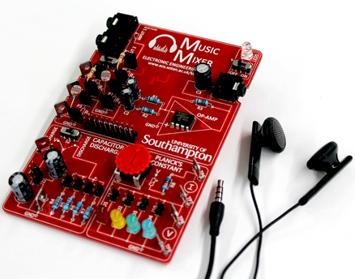

Schedule
Preparation time |  | : | 10 minute introductory talk
Lab time |  | : | 2-3 hours
Items provided
Components |  | : | Music Mixer PCB  Light dependent resistor (LDR) x2  Fixed resistors (1kΩ, 4.7kΩ, 10kΩ, 47kΩ and 100kΩ)  Jumpers  Audio cables
Equipment |  | : | Signal generator  Headphones  Oscilloscope  Multimeter (benchtop x1 and handheld x1)
You will undertake this laboratory exercise in a pair. Before starting, we recommend that you have a quick read through all sections of these notes so that you have an idea of what you are going to be doing in the lab.
Revision History
July 20, 2018 | Dr Daniel Spencer (dcs) |  |  | Version 1.4

Aims, Learning Outcomes and Outline
This special Music Mixer electronics laboratory exercise aims to:
- Give you an overview of the uses and capabilities of the Music Mixer Kit
Having successfully completed the lab, you will be able to experimentally:
- Understand potential dividers with both DC and AC signals
- Mix two different AC signal and observe the interference of waves.
- Measure the resistance characteristics of light dependent resistors.
- Observe the exponential decay of capacitor voltage as it is discharged through a resistor
- Measure the voltage-current characteristics of light emitting diodes and use this data to estimate Planck’s constant.
The lab exercise in section 2 gives you experience of using the Music Mixer board to demonstrate the principles of potential dividers. The circuit will then be used to demonstrate the principles of constructive and destructive wave interference. Section 3 explains how to use the capacitor discharge section and section 4 describes the measurement of the current-voltage characteristics of light emitting diodes and uses this data to estimate Planck’s constant.
If you need any help at any stage, please ask one of the academics or demonstrators who will come and help you.

Music Mixer
In this section you will use the top half of the Music Mixer PCB. Start by watching the video on how to use the Music Mixer. Note that in this lab we will be using the benchtop signal generator, but the mobile phone app shown in the video can also be used.

Potential divider (DC).
We will start by measuring the output voltage of a potential divider circuit using a DC signal. Switch S1 is used to isolate the potential divider created by resistors R_{A} and R_{B}. With S1 moved to the right, 5V is connected to the top of the divider (TP1). Resistors can be plugged into the sockets labelled P1-P4. The voltage drop across the two resistors can be measured using the three test points (TP1-3)
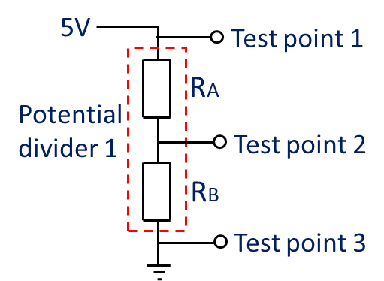
Figure 1. The potential divider circuit when switch S1 is moved to the right.
- Turn on the power and ensure the power light (LED5) is lit. Move switch S1 to the right.
- Connect the voltmeter to measure the voltage between test point 1 and test point 3. To use the benchtop multimeter plug in the red and black test leads to the “V” and “COM” powers as shown in Figure 2. Press the “DC V” button circled in red.
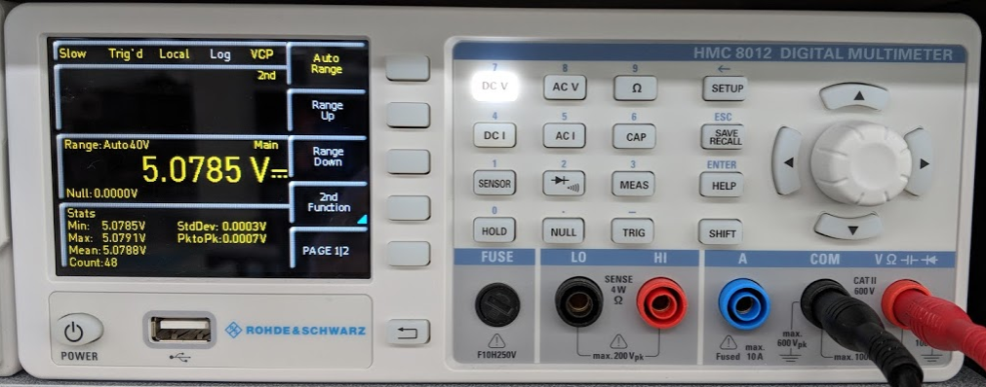
Figure 2. Image of the benchtop multimeter showing the configuration to measure voltage.

- Note down this supply voltage in the table below.
- Plug in a 4.7kΩ resistor between P1 and P2, and a 4.7kΩ resistor between P3 and P4.
- Measure the voltage between TP2 and TP3 and complete the first row of table 1.
- If the two resistors are equal, the voltage should be exactly half the supply voltage. The resistors have a tolerance of 5% (gold band) or 1% (brown band). Calculate the expected maximum and minimum voltage and check if your measured voltage is within this range.
- Choose different values of R_{A} and R_{B} and complete the table below.
Supply voltage (V_{IN}) | R_{C} (Ω) | R_{D} (Ω) | Expected Vout (V)  V_{OUT} = V_{IN}*R_{D}/(R_{C}+R_{D}) | Measured V_{OUT} (V)
 | 4.7K | 4.7K

- The fixed value resistors can be replaced with light dependent resistors (LDRs). Connect a LDR between P1 and P2, and a 4.7kΩ resistor between P3 and P4.
- Measure the output voltage and calculate the resistance of the LDR at different light intensities. Try measuring with the LDR uncovered and then obstructing the light with paper (1, 2 and 3 sheets thick). Does the resistance increase or decrease with light level?
Supply voltage (V_{IN}) | R_{C} (Ω) | R_{D} (Ω) | Measured V_{OUT} (V) | Calculate R_{C} (Ω)
 | LDR Ambient | 4.7K
 | LDR (1 sheet) | 4.7K
 | LDR (2 sheets) | 4.7K
 | LDR (3 sheets) | 4.7K

Potential dividers (AC)
Potential dividers can also be used to divide an AC signal. We are now going to connect the Music Mixer to a signal generator and an oscilloscope. If you need any help, please just ask one of the demonstrators.
Plug one 10KΩ resistor between P1 and P2 (i.e. R_{C} = 10KΩ), one between P3 and P4, one between P5 and P6, and one between P7 and P8, so that R_{A} = R_{B} = R_{C} = R_{D} = 10KΩ. Make sure switch S1 is in the left “music” position.
Turn on the oscilloscope, and waveform generator and reset them all to their default settings following these steps:
- Waveform generator: press 'Utility' -> ‘Set to Default’ -> ‘OK’
- Oscilloscope: press 'Default Setup' button under the screen
Adjust the amplitude of the waveform generator channel 1 by pressing the blue button next to ‘Ampl’, then enter ‘0.5’ using the number pad, then press the blue button next to ‘Vpp’.
Next press the blue and yellow ‘CH1|CH2’ button.
Set the amplitude of channel 2 by pressing the blue button next to ‘Ampl’, then enter ‘0.5’ using the number pad, then press the blue button next to ‘Vpp’. Check that the display looks like this:
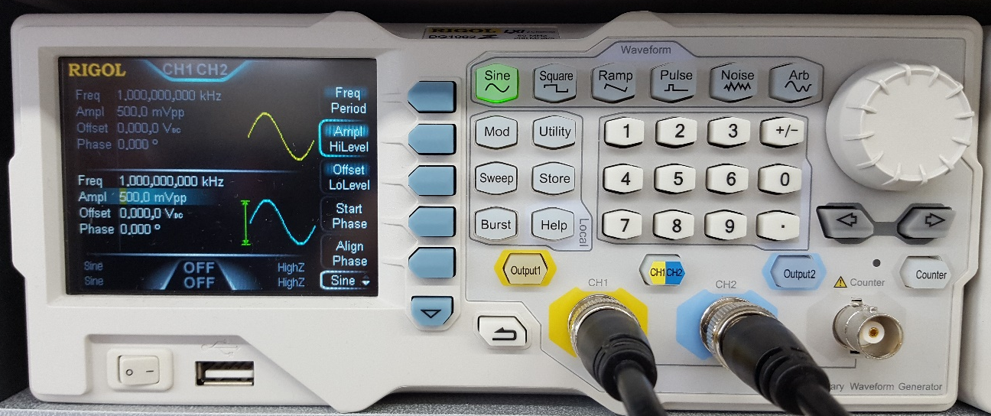

Now connect the signal generator and oscilloscope to the Music Mixer board as follows:
- Plug the headphone splitter into inputs 1 and 2 and a 3.5mm plug to ‘bare wires’ cable into the splitter.
- Use a ‘BNC to grabber’ cable to connect signal generator channel 1 to one of the cables, and a second ‘BNC to grabber’ cable to the other cable. The white/red coated wire should connect to the red grabber, and the bare wire to the black grabber.
- Connect the output to the oscilloscope using a 3.5mm plug to ‘bare wires’ cable. Connect an oscilloscope probe to the bare wires: the main part of the probe should clip onto the red or white coated wire, and the crocodile clip should connect to the bare wire.
Turn on channel 1’s output by pressing the ‘Output1’ button.
Next, observe the output signal on the oscilloscope. Push the ‘Autoset’ button to set up the view. Ask a member of staff how to measure signals on the oscilloscope, if you are not confident with doing this yourself. What is the gain of the mixer circuit?
Now turn on channel 2’s output by pressing the ‘Output2’ button.
Press ‘Start Phase’ on the waveform generator, and then use the knob to adjust the phase of output 2. Note: Press ‘Align Phase’ each time you adjust any setting, to synchronise the two signals. Observe the effect of phase difference on the oscilloscope (try 0⁰, 90⁰ and 180⁰).
Shown below, (a) is channel 1 alone, (b) is channel 1 and channel 2 with 0⁰ phase offset, and (c) is channel 1 and channel 2 with 180⁰ phase offset. Which of these illustrate constructive or destructive interference?

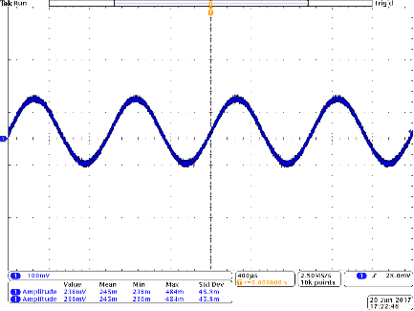  (a) | 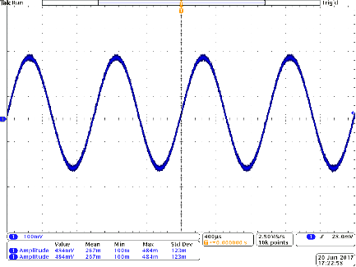  (b) | 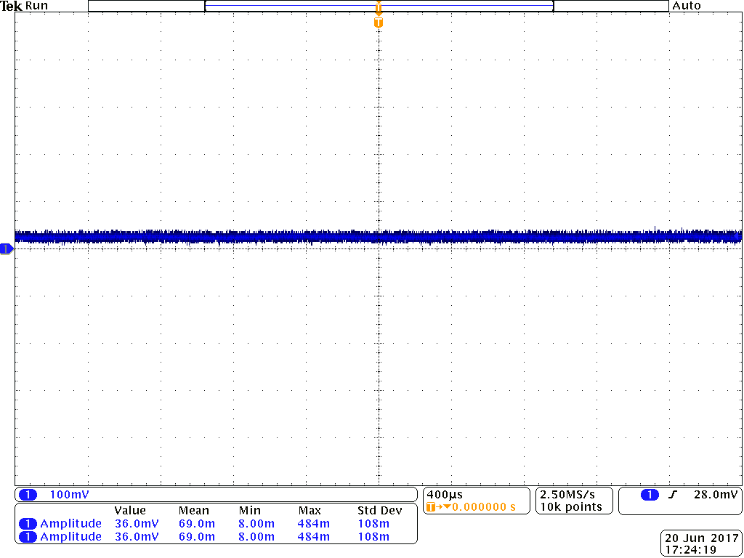  (c)

The opamp circuit can also be used to mix different frequency signals. Adjust the phase of both signals back to zero, and then try adjusting the frequency of output 2, keeping the frequency of output 1 at 1kHz. You should observe ‘mixing’ of the two signals, e.g. try (a) 2kHz, (b) 4kHz and (c) 20kHz.
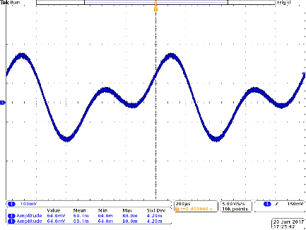  (a) | 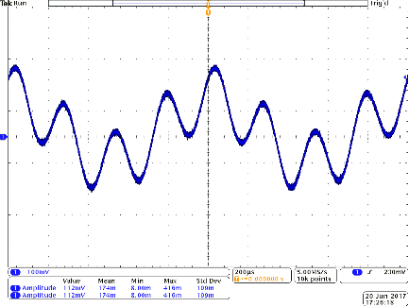  (b) | 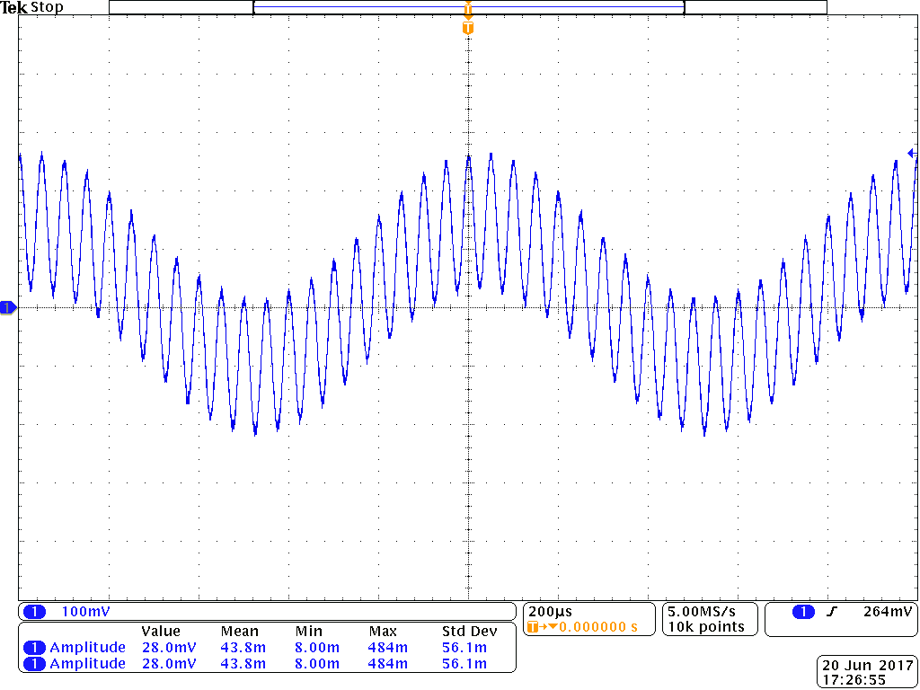  (c)

There are a number of free applications that can be used to generate signals. One example of an Android is Function Generator by Keuwlsoft (screenshot in Figure 3) which be used to generate signals from a mobile phone. The application is a dual function generator and can vary the amplitude, frequency and phase difference between channel 1 and 2. The app also supports more advanced features including AM and FM modulation.
Note: When using the app, make sure that the output is off in the app (circled in red in Figure 3) when plugging and unplugging from the board. Also limit the volume in the phone to ~75% of the maximum volume.
The first channel of the app fed into the left channel of the headphone jack and the second channel into the right channel of the headphone jack. To set this up, plug the “airplane” headphone adapter to the music mixer and use an audio cable to plug into a mobile phone. This adapter is used to connect the left and right channels to the first and second inputs on the Music Mixer board. To use with the audio mixer board, plug in the phone and insure resistor R_{A} R_{B}, R_{C} and R_{D} are all the same value as R1 (4.7kΩ).
There are free Windows apps that use the soundcard to generate signals, an example is shown in Figure 4 and can be downloaded from the link in the footer. Please ask if you would like help to set this up.
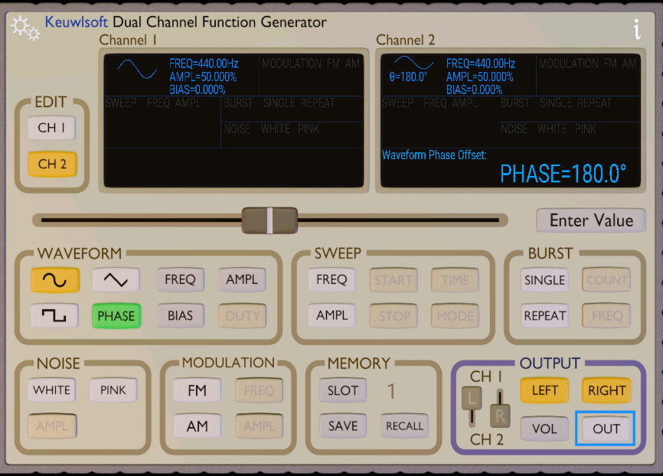
Figure 3. Screenshot of the free mobile phone signal generator app.
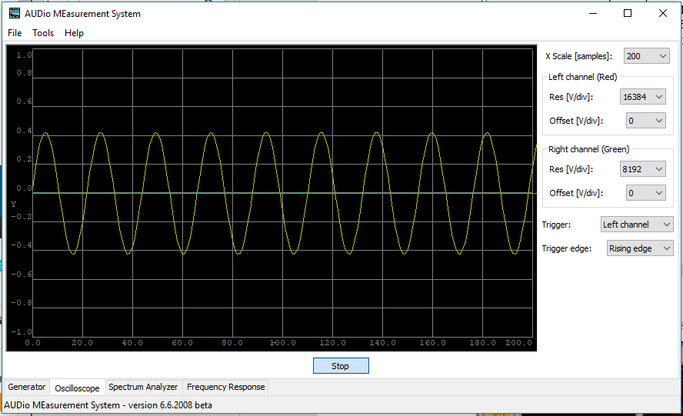
Figure 4. Screenshot of the free Windows signal generator and osilloscope app.

Capacitor discharge.
This exercise will introduce you to the discharge of stored energy in a capacitor across a resistor. Start by watching the video. The printed circuit board has the choice of four resistor values and two capacitors through the placement of jumpers. The voltage across the capacitor and resistor can be measured using the test-points on the board. The capacitor can be charged and discharged through the use of a switch on the board. The switch S3 controls the charging and discharging of the capacitors, C4 and C5 which both have a value of 470µF. By appropriate choice of jumper configuration, C4, C5 or a parallel or series combination of C4 and C5 can be selected. A discharge resistance can be selected using jumpers J3, J4, J5 and J6 to select resistor values of 22k, 47k, 68k or 100kΩ respectively.
To setup the experimental capacitance and resistance, connect a jumper to J1, J2 or both, to select one capacitor or two capacitors in series or parallel as per the figure below. Also connect a jumper to either J3, J4, J5 or J6 to set the desired discharge resistor. Connect a voltmeter or oscilloscope across TP4 and TP5 to measure the voltage across the capacitor and resistor.
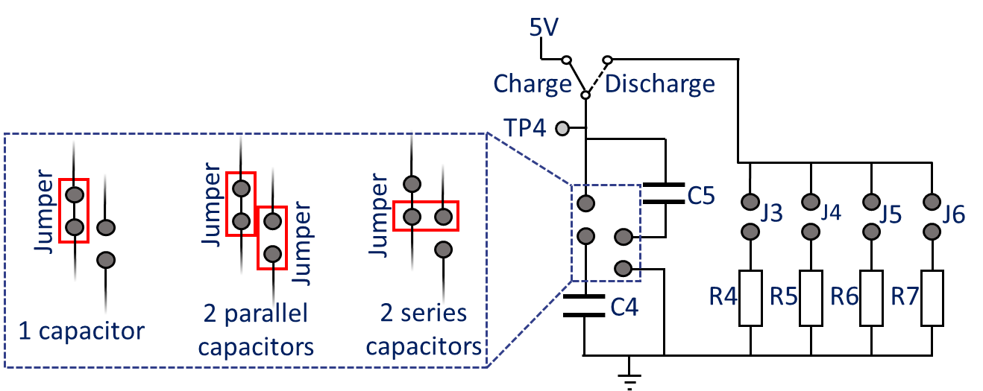
Figure 5. Overview of the capacitor discharge circuit showing the different configurations of jumpers to select a series or parallel combinations of capacitor.
Slide switch S3 to the charge position. This will connect the capacitor to the 5V battery source and charge the capacitor within 1 second. Next slide S3 to the discharge position and observe the change in voltage over time as the capacitor is discharged through the resistors.

Immediately after the switch is set to discharge, the voltage observed is: ___________ V
The voltage drops faster with a _____________ (lower/higher) value resistor.
The rate of voltage decrease _____________ (increases/decreases) over time.
The exponential decay can also be captured using the oscilloscope.
- Connect capacitor C4 to the circuit (using J1 only) and connect resistor R4 by connecting jumper J3.
- Connect the oscilloscope probe to TP4 and the probe croc clip to TP5.
- Change the horizontal axis to 2 seconds per division.
- Push switch S2 on the music mixer to the left to charge the capacitor.
- On the oscilloscope press “single” and then ~1 second later, move switch S2 to the right. The trace on the oscilloscope will move across the screen and stop at the end of the screen.
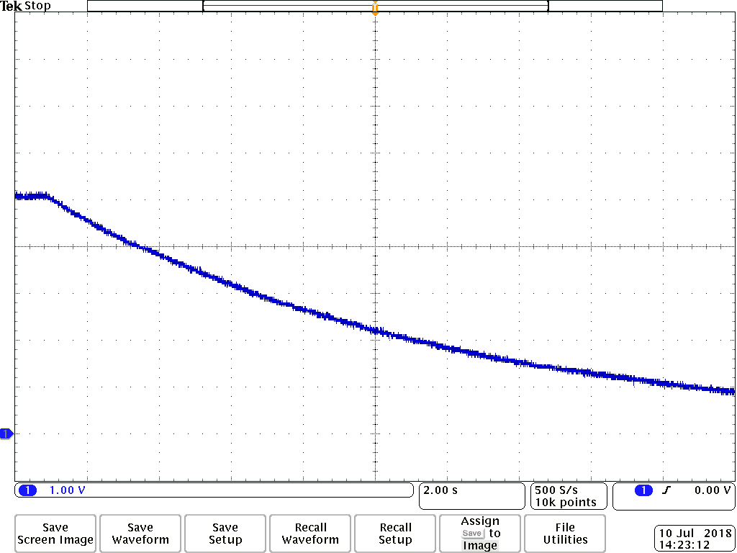
Figure 6. Example oscilloscope trace showing the expoential decay of the voltage across a capacitor when discharged through a 22kΩ resistor. Horizontal and vertical gridlines are 2 seconds and 1V respectivly.
Below is an extract copied from the AQA A-level Physics practical handbook (Experiment 9) which can be performed using the board.
- Switch to position B, start the stopclock, and observe and record the voltage reading at time t = 0. Continue to take voltage readings at 5 s intervals as the capacitor discharges. (For a slower discharge, voltage readings at 10 s intervals will be sufficient).
- Repeat the process with the same capacitor and different resistors.
- The process can also be repeated with different capacitors.
- Plot a graph of pd across the capacitor, V, on the y-axis against time, t. This should give an exponential decay curve, as given by the equation $\text{V = }{\text{V}}_{\text{0}}{\text{e}}^{\text{–t/RC}}$
- To confirm that this is an exponential, plot a graph of Ln(V/V) on the y-axis against t.
This will give a straight line graph with a negative gradient according to the ‘log form’ of the equation $ln$(V) = ln(V₀) - t/RC

This graph will have a gradient of $\frac{\text{- 1}}{\text{RC}}$

Hence the time constant RC can be determined from the gradient of the graph. If R is known, the value of C can also be found.
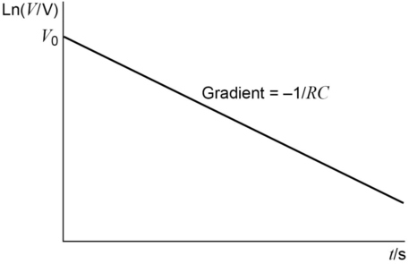

Planck’s constant
By measuring the current-voltage characteristics of different colour light emitting diodes (LEDs), Planck’s constant can be estimated. Start by watching the video. Using the bottom right section of the board, jumpers J7-J10 are used to select an LED. An ammeter is connected in series with the LED to measure the current flowing though the LED and a voltmeter is connected to measure the voltage across the LED. The variable resistor is rotated to adjust the brightness of the brightness of the LED.
- Download the spreadsheet
- Connect a jumper to J7 to connect the red LED. Please note that the LED will not light.
- Connect an ammeter between TP6 and TP7. Rotate the variable resistor. The LED should now light and the current should vary from approximately 0 to 5mA.
- Connect a voltmeter between TP8 and TP9.
- Rotate the variable resistor until the current reads 0.5mA. Record the voltage in the top left highlighted box in the spreadsheet.
- Now rotate the variable resistor until the current reads 1mA and record the voltage in the spreadsheet.
- Repeat for currents of 1.5, 2, 2.5 and 3mA. Then move the jumper to J8, J9 and then J10 to repeat for the green, yellow and blue LED respectively.
The spreadsheet (see example below) estimates the threshold (turn on) voltage of the LED by extrapolating the voltage-current curves back to a current of 0mA. The gradient of the activation voltage vs 1/wavelength can be used to estimate Planck’s constant. Please see the link in the footer for further assumptions used in the calculation.

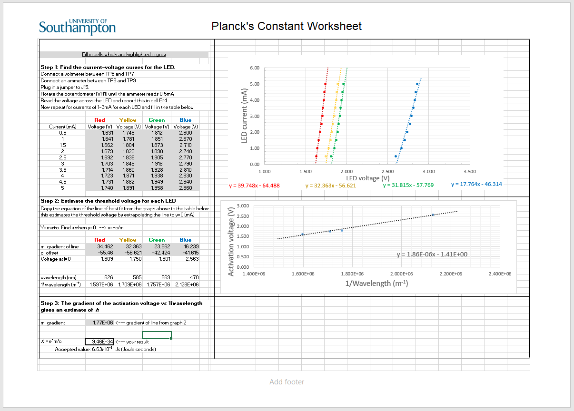
Figure 7. Planck’s constant experimental spreadsheet with “model” answers.

The blue LED appears much brighter than the red, yellow and green LEDs. These three LEDs are made using the same GaP semiconductor substrate, while the blue LED is fabricated using a different semiconductor (GaN) and is more efficient. The ideal LEDs for the experiment should have clear lenses, unlike the coloured lenses in our design. However, LEDs with clear lenses tend to be very bright and the coloured lenses allow students to easily identify which LED is which, without powering on the board.

https://www.ecs.soton.ac.uk/outreach/kits/physics-music-mixer-kit#musicmixer
https://sourceforge.net/projects/audmes/files/latest/download?source=typ_redirect Please note this website/software is provided only as a suggestion, and the University of Southampton cannot be held responsible for any content or software downloaded.
https://www.ecs.soton.ac.uk/outreach/kits/physics-music-mixer-kit#capacitordischarge
https://www.ecs.soton.ac.uk/outreach/kits/physics-music-mixer-kit#plancksconstant
https://www.ecs.soton.ac.uk/sites/www.ecs.soton.ac.uk/files/Plancks-Constant-Spreadsheet.xlsx
https://www.scienceinschool.org/2014/issue28/planck
Datasheet here: https://docs.broadcom.com/docs/AV02-1557EN
Datasheet here: http://www.farnell.com/datasheets/1911509.pdf

